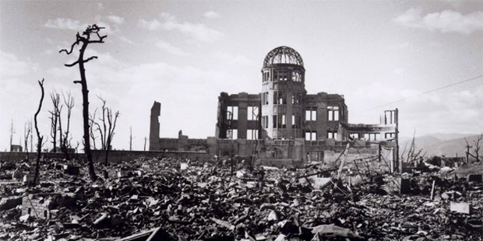

- What do you see in the picture?
- What do you think happened to the people who were here?
- Which of the following words best describes the picture? Explain Why?
  - Destruction
  - Devastation
  - Exterminate
  - Demolish
Below are two different viewpoints regarding Truman’s decision to drop the atomic bomb. Read each one and answer the questions that follow.

Viewpoint 1: Herbert Feis: “Our right, legal and historical, to use the bomb may thus well be defended; but those who made the decision to use it were not much concerned over these considerations, taking them for granted. Their thoughts about its employment were governed by one reason which was deemed imperative; that by using the bomb, the agony of war might be ended more quickly.
The primary and sustaining aim from the start of the great exertion to make the bomb was military, and the impelling reason for the decision to use it was military- to end the war victoriously as soon as possible.”

Viewpoint 2: Gar Alperovitz: “Quite simply, it is not true that the atomic bomb was used because it was the only way to save the ‘hundreds of thousands’ or ‘millions’ of lives as was subsequently claimed. The readily available options were to modify the surrender terms and/or await the shock of the Russian attack. Perhaps it is here, most poignantly, that we confront our own reluctance to ask the difficult questions-for even if one were to accept the most inflated estimates of lives saved by the atomic bomb, the fact remains that it was an act of violent destruction aimed at large concentrations of noncombatants.”

- Which viewpoint supports Truman’s decision to drop the atomic bomb?
- Underlined the statement in the viewpoint that proves your answer to #1.
- Which viewpoint do you agree with? Why?
- In the viewpoint that opposes Truman’s decision, what reasoning does the author give for his opposition?

