Below are two excerpts from speeches given by President Roosevelt prior to Pearl Harbor. Read both carefully.

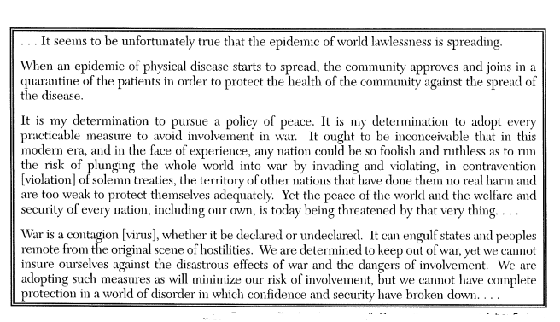

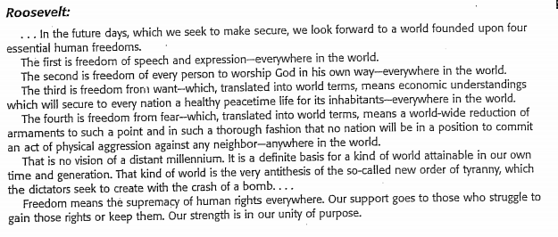

- According to the documents, what are the two viewpoints President Roosevelt expresses in each speech about United States involvement in war?
- How does Roosevelt’s viewpoint change from the first speech to the second speech?

- In the first speech, which words does Roosevelt use to describe war as a disease?

- In the second speech which sentence provides evidence that Roosevelt believed the United States may have to get involved in the war?

