Read the excerpt below about Malcolm X and Dr. Martin Luther King, Jr. Then answer the questions that follow.

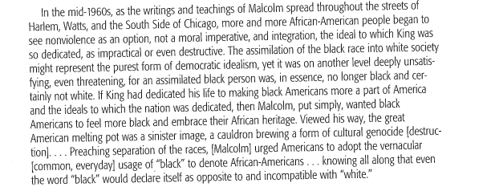

- What problems or concerns did some African Americans in the 1960’s begin to have with the idea of integration?

- What alternatives did Malcom X provide to African Americans?

- The assimilation of the black race into white society might represent the purest form of democratic idealism.

In the statement above choose the best word to replace the underlined word.

- Consumption
- Taking in
- Nationalization
- Adaptation

- How might the civil rights movement of the 1950’s and early 1960’s have differed had it been based on Malcolm X’s ideas of separating from white society rather than on Martin Luther King, Jr.’s ideas of assimilating with whites? Explain your answer.

