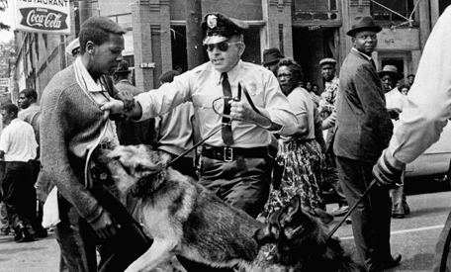

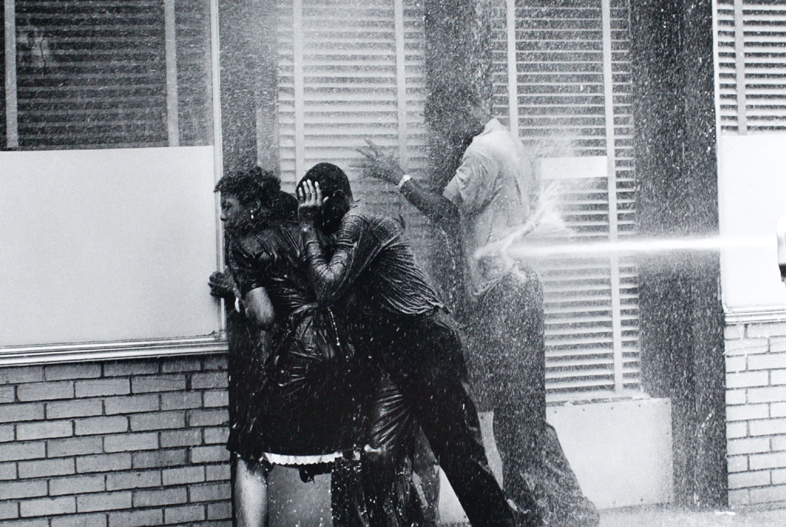

In two or three sentences, describ the images in terms of people, activities, objects, places etc.

Warm Up “Letter from Birmingham Jail”
Dr. Martin Luther King, Jr., was arrested and jailed many times during his crusade to end segregation and advance the cause of racial equality. In 1963 he was imprisoned for leading a demonstration in Birmingham, Alabama. While in prison there, he wrote the following letter to members of the clergy who had criticized him for using direct-confrontation tactics and for “moving too quickly” to change race relations in the south.
Read Dr. King’s letter (excerpt) and aswer the questions that follow.

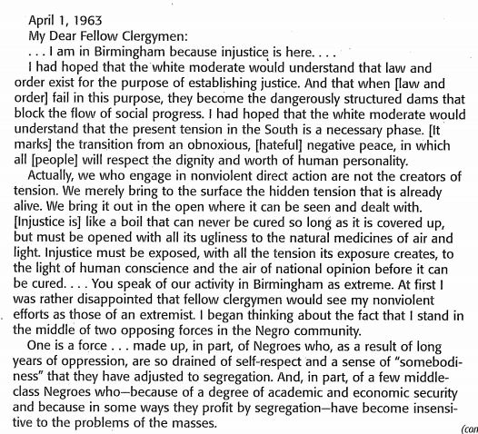
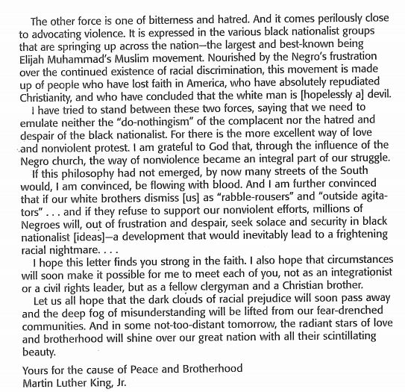

- According to Dr. King, what are the two opposing forces in the African American community?
- To what should injustice be exposed in order to heal it?

How does Dr. King appeal to the reader? Logos, Pathos, Ethos
Underline two sentences in the excerpt that use logos as an appeal: (appeal to logic)
Underline two sentences in the excerpt that use pathos as an appeal: (appeal to emotion)
Underline one sentence in the excerpt that use ethos as an appeal: (appeal to authority or reputation)

