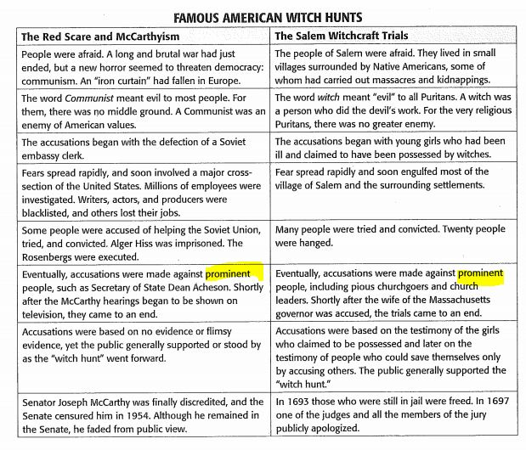
Authors have made connections between the Red Scare and the McCarthy era of the late 1940s and early 1950s and the Salem witchcraft trials of 1692. Study the chart below to decide whether or how history repeated itself.
Answer the following questions based on the table above.
- What are the major similarities between the events of the Red Scare and the McCarthy era and the Salem witchcraft trials?

- What are the major differences between the events of the Red Scare and the McCarthy era and the Salem witchcraft trials?

- Choose two words below that would best replace the highlighted words in the chart.

Larger
Excellent
Outstanding
Preferable
Noticeable

- Which word best expresses the central idea of the chart?
- Religion
- Evil
- Fear
- accusations

