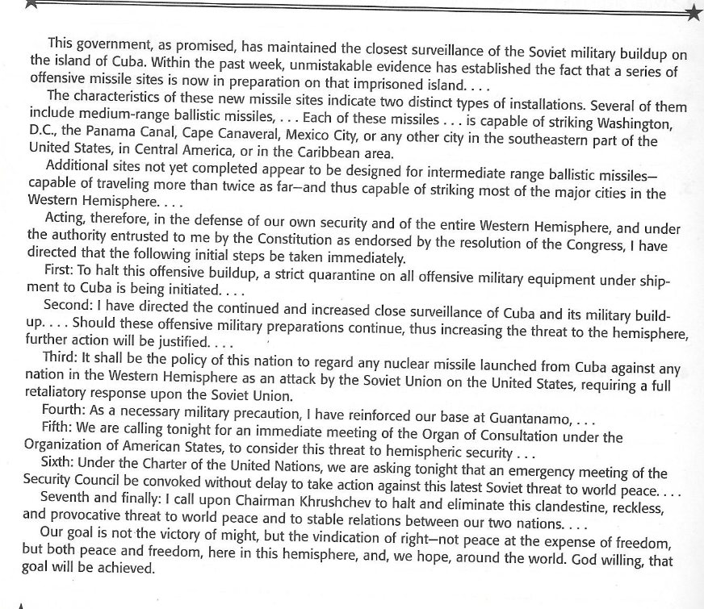
https://www.youtube.com/watch?v=W50RNAbmy3M
Go to the video link above and watch an excerpt from President Kennedy’s Cuban Missile Crisis Speech.

Read the excerpt above from President Kennedy’s October 22, 1962, television address concerning the Cuban missile crisis. Then answer the questions that follow.

- Highlight the sentence that supports this statement: The President has the power to begin action to defend the United States against Soviet aggression.
- Read the sentence from the text.
To halt this offensive buildup, a strict quarantine on all offensive military equipment under ship-
ment to Cuba is being initiated…..

What does the word quarantine most likely mean?
A: to prevent the spread of disease
B. to attack
C. to seize
D to restrain movement
- What does Kennedy maintain is the purpose for Soviet military buildup in Cuba?
- To provide Cuba a defense against the United States
- To provide a nuclear strike capability against the western hemisphere.
- To assist them in finding additional sites to place their intermediate range ballistic missiles.
- To build up Soviet missiles to attack Mexico.
- Which to actions does President Kennedy directly address the aggressor?
- Third and Seventh
- First and Fifth
- First and Second
- Fourth and Fifth

