Warm Up Civil Rights Act of 1964

Read the statement below and answer the questions that follow:

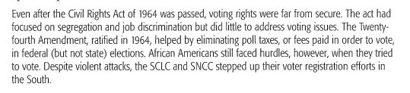

- Choose the best word to replace the word hurdles, in the second to the last sentence in the statement above.
- Laws
- Barrier’s
- Discrimination
- Difficulties

- List 3 important facts listed I the statement above.

1._______________________________

2________________________________

3___________________________________

