APUSH UNIT 7 READING GUIDE Name:______________________________

UNIT 7
WWII & THE COLD WAR

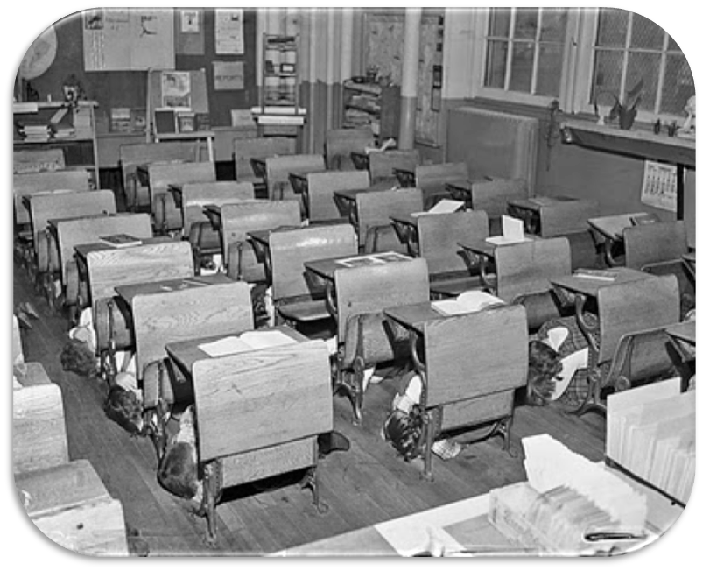

Chapter 23 | Chapter 24 | Cold War Homefront | Civil Rights Movement | Chapter 25

CHAPTER 23: WORLD WAR II

KEY TERM | EXPLANATION
Munich Agreement
Good Neighbor Policy
Four Freedoms
Korematsu v. U.S.
G.I. Bill

KEY QUESTION | EXPLANATION
Why was the American public isolationist in the 1930s? What steps did America take to try and remain neutral prior to WWII?
What steps did Germany and Japan take to lead America into WWII?
What were the major consequences of the Lend-Lease Act?
How was America transformed from a peacetime to a wartime economy? What were the steps that America took to mobilize for WWII?
Describe the war’s effects on minority groups on the homefront. How did the war change the lives of... | WOMEN | AFRICAN-AMERICANS
Describe the war’s effects on minority groups on the homefront. How did the war change the lives of... | HISPANIC-AMERICANS | JAPANESE-AMERICANS
Describe the major turning points of the war in the Pacific.
Describe the major turning points of the war in Europe.
What were the major dilemmas and actions discussed during the “Big 3” meetings? | TEHRAN | YALTA
 | POTSDAM
According to Kevin Schultz, was the U.S. justified in dropping the atomic bombs on Hiroshima and Nagasaki? What evidence does Schultz use to support his opinion?
What were the costs of World War II (consider all participants), and how did it transform America’s role in the world?

