Iran-Contra Affair
The Iran-Contra Affair was a clandestine action not approved of by the United States Congress. It began in 1985, when President Ronald Reagan's administration supplied weapons to Iran¹ — a sworn enemy — in hopes of securing the release of American hostages held in Lebanon by Hezbollah terrorists loyal to the Ayatollah Khomeini, Iran's leader. This article is rooted in the Iran Hostage Crisis.
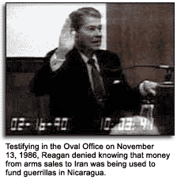
The U.S. took millions of dollars from the weapons sale and routed them and guns to the right-wing "Contra"² guerrillas in Nicaragua. The Contras were the armed opponents of Nicaragua's Sandinista Junta of National Reconstruction, following the July 1979 overthrow of strongman Anastasio Somoza Debayle and the ending of the Somoza family's 43-year reign.
Illegal trading
The transactions that took place in the Iran-Contra scandal were contrary to the legislation of the Democratic-dominated Congress and contrary to official Reagan administration policy.
Part of the deal was that, in July 1985, the United States would send 508 American-made TOW anti-tank missiles from Israel to Iran for the safe exchange of a hostage, the Reverend Benjamin Weir.
After that successful transfer, the Israelis offered to ship 500 HAWK surface-to-air missiles to Iran in November 1985, in exchange for the release of all remaining American hostages being held in Lebanon. Eventually the arms were sold with proceeds going to the contras, and the hostages were released.
In February 1986, 1,000 TOW missiles were shipped to Iran. From May to November, there were more shipments of various weapons and parts.
Eventually Hezbollah elected to kidnap more hostages following their release of the previous ones, which rendered meaningless any further dealings with Iran.
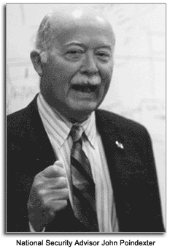
The affair is exposed
It was not until 1986 that word had gotten out about the secret transactions. The Lebanese magazine Ash-Shiraa
published a series of articles in November 1986, that exposed the weapons-for-hostages deal. On November 18th, 1987, the Congress issued a report on the affair that stated the president bore "ultimate responsibility."
Upon further investigation, Attorney General Edwin Meese verified the report and an independent special prosecutor, Lawrence E. Walsh, was assigned to investigate the deals involving the arms sale and the Contra support.
President Reagan appointed a review board, headed by former Republican Senator John Tower. The Tower Commission's report concluded that the president had been inefficient in controlling the National Security Council, the agency that had actually made the illegal deals, and had known about the arms sale to the Iranians. However, it could not be discovered in hearings if the president had known about the Contra support.
Court hearings and convictions
The hearings surrounding the scandals were televised from May to August in 1987. Military aide Marine Lt. Colonel Oliver North, former CIA chief William J. Casey, National Security Advisor John Poindexter, former defense secretary Caspar Weinberger, and many other high-ranking government officials were publicly investigated.
It was finally found that National Security Advisor Poindexter had personally authorized the diversion of money to the Contra rebels; all the while withholding the information from President Reagan. The CIA's William J. Casey played a part in the conspiracy, but he died during the hearings.
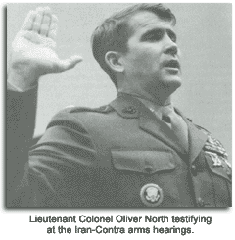
As a military aide to the National Security Council, North had been the main negotiator. During his hearings he repeatedly explained that he was "under orders from his superiors." North's plea of innocence was overlooked, and in May 1989, he was convicted of obstructing Congress and unlawfully destroying government documents. A few years later, when George H.W. Bush was president, North's conviction was expunged on the grounds that he had acted strictly out of patriotism.
Poindexter was convicted in April 1990 on five counts of deceiving Congress and sentenced to six months in prison. Two years later, Weinberger also was convicted of five counts of deceiving Congress. Both Poindexter and Weinberger's convictions were overturned — which relieved them of any accumulated responsibility.
On Christmas Eve 1992, President Bush issued presidential pardons to all indicted in the scandal. The Iran-Contra Affair was ended.

