APUSH UNIT 4 READING GUIDE Name:______________________________

UNIT 4
THE CIVIL WAR ERA

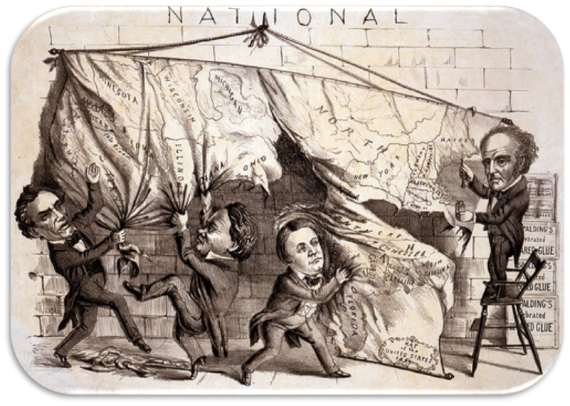

Chapter 13 | Chapter 14 | Chapter 15 | Chapter 16
CHAPTER 13: THE CONTINUED MOVE WEST

KEY TERM | EXPLANATION
Ft. Laramie Treaty
Oregon Trail
Fifty-four Forty or Fight
Manifest Destiny
Treaty of Guadalupe Hidalgo

KEY QUESTION | EXPLANATION
Explain the steps that led to Texan independence from Mexico; also explain why the United States hesitated for several years before annexing Texas. | CAUSES OF WAR OF TEXAN INDEPENDENCE | REASONS FOR U.S. HESITATION TO ANNEX TEXAS
What were the causes and consequences of the increasing migration waves into Oregon and California? | CAUSES | CONSEQUENCES
What were James K. Polk’s main goals as president and how successful was he at accomplishing these goals and achieving “Manifest Destiny”?
Why did the United States and Mexico go to war in 1846? Does Kevin Schultz (the textbook author) feel that the war was provoked by Polk? (find evidence to support your opinion)
Who led the major military campaigns during the Mexican War and how successful was each campaign?
What were the benefits and costs of the Mexican-American War both immediately and in the long run for the United States? | BENEFITS | COSTS
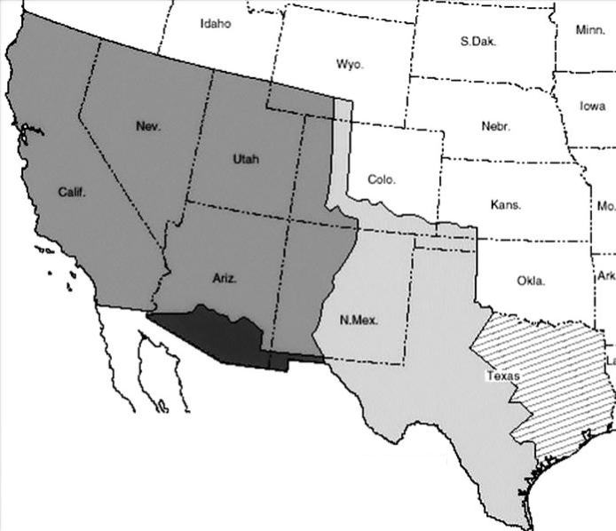

Label the following regions on the map: Republic of Texas (1836-1845); Disputed area claimed by Texas and Mexico (1836-1845); Mexican Cession (1848); Gadsden Purchase (1853)

CHAPTER 14: THE IMPENDING CRISIS

KEY TERM | EXPLANATION
Uncle Tom’s Cabin (p. 209)
Wilmot Proviso
Popular Sovereignty
Free Soil Party
Filibusters
Republican Party
Bleeding Kansas
John Brown
Crittenden Compromise

KEY QUESTION | EXPLANATION
What were the main provisions of the Compromise of 1850? Which parts benefited the North and which benefited the South? | PROVISIONS BENEFITING THE NORTH | PROVISIONS BENEFITING THE SOUTH
How did the TREATY OF GUADALUPE HIDALGO represent a turning point and push the country closer to Civil War?
How did the FUGITIVE SLAVE ACT represent a turning point and push the country closer to Civil War?
How did the KANSAS-NEBRASKA ACT represent a turning point and push the country closer to Civil War?
How did the DEATH OF THE SECOND TWO-PARTY SYSTEM represent a turning point and push the country closer to Civil War?
How did the DRED SCOTT DECISION represent a turning point and push the country closer to Civil War?
How did the LINCOLN-DOUGLAS DEBATES represent a turning point and push the country closer to Civil War?
How did the ATTACK ON HARPER’S FERRY represent a turning point and push the country closer to Civil War?
How did the 1860 ELECTION represent a turning point and push the country closer to Civil War?

CHAPTER 15: THE CIVIL WAR

KEY TERM | EXPLANATION
Jefferson Davis
Commutation
Writ of Habeas Corpus
Copperheads
13th Amendment
March to the Sea
Appomattox

KEY QUESTION | EXPLANATION
At the outbreak of war, what advantages did the Confederacy have and what advantages did the United States have? | CONFEDERATE STATES | UNITED STATES
What were the war strategies for each side in the Civil War? | CONFEDERATE STATES | UNITED STATES
Compare and contrast the military leadership of George McClellan and Robert E. Lee | GEORGE MCCLELLAN | ROBERT E. LEE
Provide examples of how the USA and CSA exerted greater control over the lives of their citizens and became more powerful nation-states. Additionally, how did citizens react to these changes? | EXAMPLES OF EXERTION OF GREATER CONTROL | REACTIONS FROM CITIZENS
Which states were Border States and how did they influence Lincoln’s statements and actions concerning slavery throughout the war?
How did the following events represent important turning points in the Civil War? | BATTLE OF ANTIETAM | EMANCIPATION PROCLAMATION
 | BATTLE OF GETTYSBURG | BATTLE OF VICKSBURG
How did African Americans shape the course of the Civil War?
How did the Gettysburg Address give the Civil War AND the Constitution a new meaning? (look beyond the textbook)
What was the political situation as the election of 1864 approached, and how did Lincoln win a reelection?
Why was the United States ultimately able to win the Civil War and force the Confederacy to surrender?
Assess the significance of the Civil War in terms of its impact on... | THE SOUTH | THE STRENGTH OF THE FEDERAL GOVERNMENT
 | INDUSTRY | AMERICAN NATIONALISM
 | WOMEN | RELIGION
 | PHILOSOPHY | AFRICAN AMERICANS (look beyond the textbook)
What is the “Lost Cause” myth and how is it still present in the United States today? (p. 320-321)
CHAPTER 16: RECONSTRUCTION

KEY TERM | EXPLANATION
Freedmen’s Bureau
Black Codes
Radical Republicans
14th Amendment
15th Amendment
Scalawags/Carpetbaggers
Sharecropping
Civil Rights Cases
Mississippi Plan
Redeemers
Compromise of 1877
Jim Crow laws (p. 318)
Plessy v. Ferguson (p. 318)
Second Mississippi Plan (p. 318)

KEY QUESTION | EXPLANATION
What were the main dilemmas of Reconstruction that the federal government needed to resolve?
How did former slaves respond to freedom? What institutions did they embrace?
What was Lincoln’s plan for Reconstruction, and what modifications did Johnson make to Lincoln’s original plan?
What were the major goals and achievements of Congressional/Radical Reconstruction?
How was the women’s rights movement both emboldened and divided over the 14th and 15th amendments to the Constitution?
How was the South able to subjugate African Americans after the Civil War and bring about an end to Reconstruction? (additional info on p. 318-319)
What were the successes and failures of Reconstruction? | SUCCESSES | FAILURES

