APUSH UNIT 3 READING GUIDE Name:______________________________

UNIT 3
GROWING PAINS

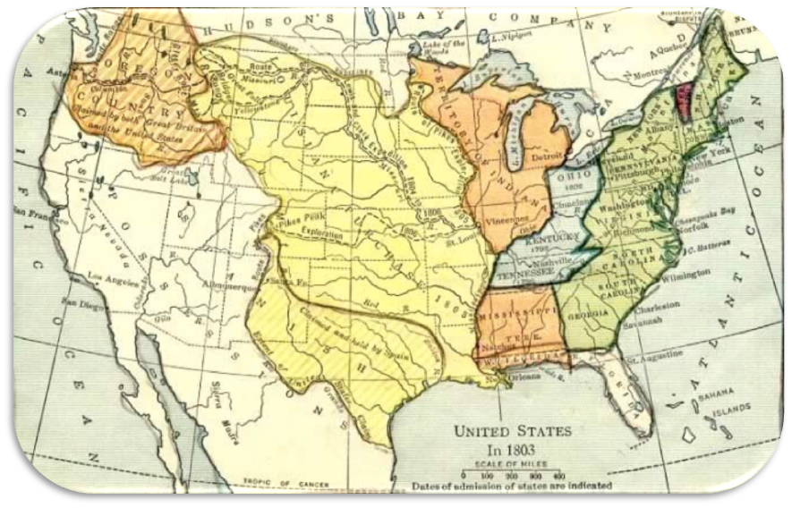

Chapter 9 | Chapter 10 (Part 1) | Chapter 10 (Part 2) | Chapter 11 | Chapter 12
CHAPTER 9: JEFFERSONIAN DEMOCRACY

KEY TERM | EXPLANATION
Marbury v. Madison
John Marshall
Tecumseh
Embargo Act
Hartford Convention
Era of Good Feelings

KEY QUESTION | EXPLANATION
What were the major successes and failures of Thomas Jefferson’s presidency? (consider domestic and foreign issues) | SUCCESSES | FAILURES
How was the United States able to acquire the Louisiana Territory and why did Jefferson struggle with the purchase?
What were the major causes of the War of 1812?
What were the main military engagements in the War of 1812? Explain the outcome/significance of each event. (Also, label the 3 main theaters of the war on the map) | 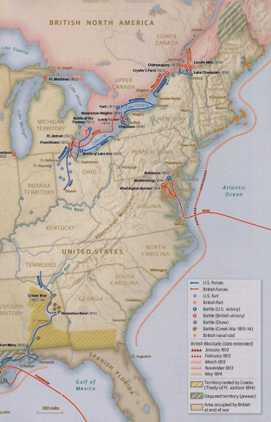
What made the War of 1812 a significant turning point in American history?

CHAPTER 10 (PART 1): THE MARKET REVOLUTION, p. 167-179

KEY TERM | EXPLANATION
Market Revolution
Internal Improvements
Monroe Doctrine
John Quincy Adams (look for info beyond textbook, why was he an important Secretary of State?)
Turnpike
Cult of Domesticity
Lowell System

KEY QUESTION | EXPLANATION
How did Henry Clay’s American System aim to increase national unity and economic development?
How did Justice John Marshall’s Supreme Court decisions strengthen the power of the federal government? (p. 169 and link on Unit 3 page of class website)
What motivated the creation of the Monroe Doctrine and what were its main assertions?
How did the turnpike, canal, steamboat and railroad transportation revolutions change the American economy? | TURNPIKE | CANAL
 | STEAMBOAT | RAILROAD
How did the following innovations facilitate turning points in American history? | ERIE CANAL | SAMUEL MORSE’S TELEGRAPH
 | ELI WHITNEY’S COTTON GIN
How did the market revolution increase national unity, but also increase distinctive regional identities at the same time? | INCREASE NATIONAL UNITY | INCREASE REGIONAL IDENTITIES
How did industrialization impact the lives of women and children? (p. 177, 179 and 208

CHAPTER 10 (PART 2): THE MARKET REVOLUTION, p. 179-184

KEY TERM | EXPLANATION
2nd Great Awakening (causes and consequences)
Burned-Over District
Seneca Falls

KEY QUESTION | EXPLANATION
Explain the major components of the TRANSCENDENTALIST movement | MOTIVATION/GOALS | MAJOR LEADERS
 | SUCCESSES | FAILURES
Explain the major components of the UTOPIAN movements (include the Mormons, additional info on p. 224-226) | MOTIVATION/GOALS | MAJOR LEADERS
 | SUCCESSES | FAILURES
Explain the major components of the TEMPERANCE movement | MOTIVATION/GOALS | MAJOR LEADERS
 | SUCCESSES | FAILURES
Explain the major components of the PUBLIC EDUCATION movement | MOTIVATION/GOALS | MAJOR LEADERS
 | SUCCESSES | FAILURES
Explain the major components of the PRISON/ASYLUM REFORM movement | MOTIVATION/GOALS | MAJOR LEADERS
 | SUCCESSES | FAILURES
Explain the major components of the WOMEN’S RIGHTS movement | MOTIVATION/GOALS | MAJOR LEADERS
 | SUCCESSES | FAILURES
CHAPTER 11: POLITICS OF THE MARKET REVOLUTION

KEY TERM | EXPLANATION
Election of 1824
Corrupt Bargain
Spoils System
Suffrage
Patronage
Nullification Crisis
Indian Removal Act

KEY QUESTION | EXPLANATION
What caused American politics to become more and more “democratic” during the first half of the 1800s?
How did Andrew Jackson defend and justify his actions for each of the following events? What were the consequences of Jackson’s executive actions in each scenario? | SPOILS SYSTEM | NULLIFICATION CRISIS
How did Andrew Jackson defend and justify his actions for each of the following events? What were the consequences of Jackson’s executive actions in each scenario? | NATIONAL BANK WAR | INDIAN REMOVAL
Explain the philosophical and policy differences between the Democrats and the Whigs. | DEMOCRATS | WHIGS

CHAPTER 12: A REGIONALIZED AMERICA

KEY TERM | EXPLANATION
Missouri Compromise (p. 175-176)
Nativism
Minstrel Show
Know-Nothing Party (p. 240-241)
American Colonization Society
American Anti-Slavery Society
William Lloyd Garrison
Gag Rule
Antebellum South
Yeoman farmer
Nat Turner
Underground Railroad
Frederick Douglass

KEY QUESTION | EXPLANATION
What were the sources of America’s population growth? How did Americans react to this rapid growth? (additional info on p. 178) | SOURCES/CAUSES OF MIGRATION | AMERICAN REACTIONS
Explain the rise of Abolitionism in the United States. How did the movement evolve over time?
What were the major successes and failures of the Abolitionist movement? | SUCCESSES | FAILURES
How did slavery affect whites - those who owned slaves and those who did not; those in the North and those in the South? | SOUTH | NORTH
How did the South defend slavery? How did this defense evolve over time?
In what ways were slaves subjugated? In what ways were they allowed to have autonomy/agency? | SUBJUGATION | AUTONOMY

UNIT 3 MAP ANALYSIS:

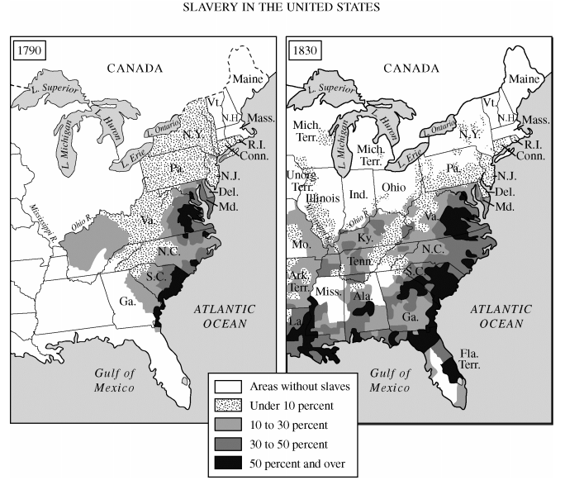
- What trends do you notice in this map?

- What caused these trends?

