GOV. MT. 2, LT. 2: The Growth of Presidential Power
President | How They Defined or Exercised Power | Important Accomplishments or Achievements | Contribution to Growth of Presidential Power
George Washington (1789-1797)
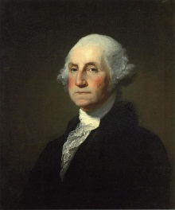

Andrew Jackson (1829-1837)
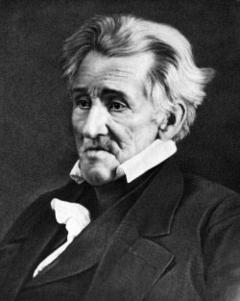

Abraham Lincoln
(1861-1865)
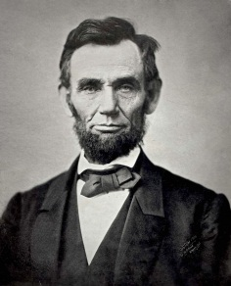

President | How They Defined or Exercised Power | Important Accomplishments or Achievements | Contribution to Growth of Presidential Power
Theodore Roosevelt
(1901-1909)
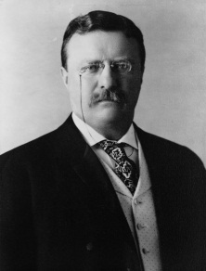

Franklin D. Roosevelt
(1933-1945)
