(B) African Americans in the Great Depression
The Great Depression brought mass suffering to all regions of the country. National income dropped by 50 percent and unemployment rose to an estimated 25 percent of the total labor force. At the same time, twenty million Americans turned to public and private relief agencies for assistance. As the "Last Hired and the First Fired," African Americans entered the Depression long before the stock market crash in 1929, and they stayed there longer than other Americans. By 1933, African Americans found it all but impossible to find jobs of any kind in agriculture or industry. As cotton prices dropped from eighteen cents per pound on the eve of the Depression to less that six cents per pound in 1933, some 12,000 black sharecroppers lost their precarious footing in southern agriculture and moved increasingly toward southern, northern, and western cities. Mechanical devices had already slowly reduced the number of workers required for plowing, hoeing, and weeding, but now planters also experimented with mechanical cotton pickers, which displaced even more black farm workers. Despite declining opportunities in cities, the proportion of blacks living in urban areas rose from 44 percent in 1930 to nearly 50 percent by the onset of World War II.
As the number of rural blacks seeking jobs in cities escalated, urban black workers experienced increasing difficulties. Black urban unemployment reached well over 50 percent, more than twice the rate of whites. In southern cities, white workers rallied around such slogans as, "No Jobs for N*****s Until Every White Man Has a Job" and "N*****s, back to the cotton fields—city jobs are for white folks." The most violent episodes took place on southern railroads, as unionized white workers and the railroad brotherhoods intimidated, attacked, and murdered black firemen in order to take their jobs. Nearly a dozen black firemen lost their jobs in various parts of the South. As one contemporary observer succinctly stated, "The shotgun, the whip, the noose, and Ku Klux Klan practices were being resumed in the certainty that dead men not only tell no tales, but create vacancies." For their part, in the North and South, black women were forced into the notorious Depression era "slave market," where even working-class white women employed black women at starvation wages, as little as $5 per week for full-time laborers in northern cities. In their studies of the market in Bronx, New York, two black women compared the practice to the treatment of slaves in Harriet Beecher Stowe's novel Uncle Tom's Cabin.
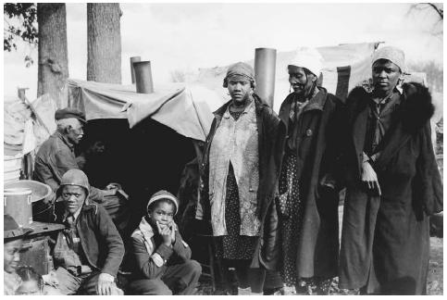

(C) Mexican Americans in the Great Depression
Most Americans are familiar with the forced relocation in 1942 of 112,000 Japanese Americans from the West Coast to internment camps. Far fewer are aware that during the Great Depression, the Federal Bureau of Immigration (after 1933, the Immigration and Naturalization Service) and local authorities rounded up Mexican immigrants and naturalized Mexican American citizens and shipped them to Mexico to reduce relief roles. In a shameful episode, more than 400,000 repatriodos, many of them citizens of the United States by birth, were sent across the U.S.-Mexico border from Arizona, California, and Texas. Texas' Mexican-born population was reduced by a third. Los Angeles also lost a third of its Mexican population. In Los Angeles, the only Mexican American student at Occidental College sang a painful farewell song to serenade departing Mexicans.
Even before the stock market crash, there had been intense pressure from the American Federation of Labor and municipal governments to reduce the number of Mexican immigrants. Opposition from local chambers of commerce, economic development associations, and state farm bureaus stymied efforts to impose an immigration quota, but rigid enforcement of existing laws slowed legal entry. In 1928, United States consulates in Mexico began to apply with unprecedented rigor the literacy test legislated in 1917.
After President Hoover appointed William N. Doak as secretary of labor in 1930, the Bureau of Immigration launched intensive raids to identify aliens liable for deportation. The secretary believed that removal of undocumented aliens would reduce relief expenditures and free jobs for native-born citizens. Altogether, 82,400 were involuntarily deported by the federal government.
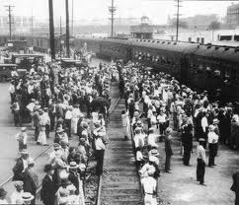

(D) Women & Families in the Great Depression
“We didn’t go hungry, but we lived lean.” That expression sums up the experiences of many American families during the 1930s: they avoided stark deprivation but still struggled to get by. The typical woman in the 1930s had a husband who was still employed, although he had probably taken a pay cut to keep his job; if the man lost his job, the family often had enough resources to survive without going on relief or losing all its possessions. Still, Eleanor Roosevelt noted, “Practically every woman, whether she is rich or poor, is facing today a reduction of income.” In 1935–1936 the median family income was $1160, which translated into $20–25 a week to cover all their expenses, including food, shelter, clothing, and perhaps an occasional treat like going to the movies. Women “made do” by substituting their own labor for something that previously had been bought with cash or by practicing petty economies like buying day-old bread or warming several dishes in the oven to save gas. Living so close to the edge, women prayed that no catastrophic accident or illness would swamp their tight budgets. “We had no choice,” remembered one housewife. “We just did what had to be done one day at a time.”
In many ways men and women experienced the Depression differently. Men were socialized to think of themselves as breadwinners; when they lost their jobs or saw their incomes reduced, they felt like failures because they couldn’t take care of their families. Women, on the other hand, saw their roles in the household enhanced as they juggled to make ends meet. Sociologists Robert and Helen Lynd noticed this trend in a study of Muncie, Indiana, published in 1937: “The men, cut adrift from their usual routine, lost much of their sense of time and dawdled helplessly and dully about the streets; while in the homes the women’s world remained largely intact and the round of cooking, housecleaning, and mending became if anything more absorbing.” To put it another way, no housewife lost her job in the Depression.
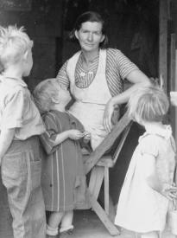

(E) Farmers in the Great Depression
At the start of the Depression, a fifth of all American families still lived on farms. These families, however, were in deep trouble. Farm income fell by a staggering two-thirds during the Depression's first three years. A bushel of wheat that sold for $2.94 in 1920 dropped to $1 in 1929 and 30 cents in 1932. In one day, a quarter of Mississippi's farm acreage was auctioned off to pay for debts.
The farmers' problem, ironically, was that they grew too much. Worldwide crop production soared--a result of more efficient farm machinery, stronger fertilizers, and improved plant varieties--but demand fell. People ate less bread, Europeans imposed protective tariffs, and consumers replaced cotton with rayon. Too much was being grown, and the glut caused prices to fall. In order to meet farm debts in 1932, farmers needed to grow 2.5 times as much corn as they grew in 1929, 2.7 times as much wheat, and 2.4 times as much cotton.
As farm incomes fell, farm tenancy soared; two-fifths of all farmers worked on land that they did not own. The Gudgers, a white southern Alabama sharecropping family of six, illustrated the plight of tenants who were slipping deeper and deeper into debt. Each year, their landlord provided them with 20 acres of land, seed, an unpainted one-room house, a shed, a mule, fertilizer, and $10 a month. In return, they owed him half of their corn and cotton crop and 8 percent interest on their debts. In 1934, they were $80 in debt; by 1935, their debts had risen another $12.
Nature itself seemed to have turned against farmers. In the South, the boll weevil devoured the cotton crop; on the Great Plains, the top soil literally blew away, piling up in ditches like "snow drifts in winter." The Dust Bowl produced unparalleled human tragedy, but it had not occurred by accident. The Plains had always been a harsh, arid inhospitable environment. Nevertheless, a covering of tough grass-roots, called sod, permitted the land to retain moisture and support vegetation. During the 1890s, however, overgrazing by cattle severely damaged the sod. Then, during World War I, demand for wheat and the use of gasoline-powered tractors allowed farmers to plow large sections of the prairie for the first time. The fragile skin protecting the prairie was destroyed. When drought struck, beginning in 1930, and temperatures soared (to 108 degrees in Kansas for weeks on end) the wind began to blow the soil away. One Kansas county, which produced 3.4 million bushels of wheat in 1931, harvested just 89,000 bushels in 1933.
Tenant farmers found themselves evicted from their land. By 1939, a million Dust Bowl refugees and other tenant farmers left the Plains to work as itinerant produce pickers in California. As a result, whole counties were depopulated. In one part of Colorado, 2,811 homes were abandoned, while an additional 1,522 people simply disappeared.
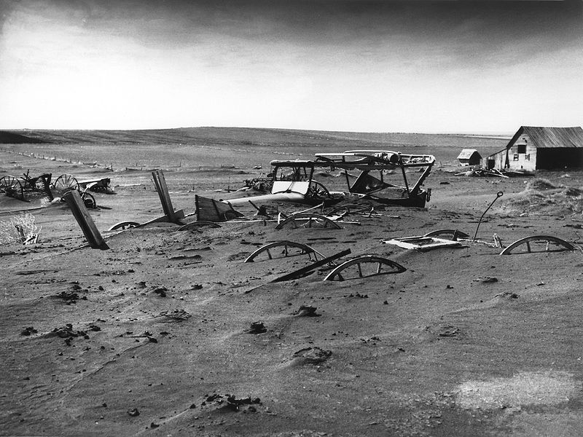
(F) Migrant Workers in the Great Depression
The Great Depression, which had begun in the 1920s for many of the nation's agricultural regions, worsened the difficulties migrant workers faced. While the numbers of workers in search of work rose during the Depression, the amount of land in production decreased. Moreover, farmers who also faced economic difficulties—falling prices for their crops, higher taxes, and increased debt—looked for places to cut costs, and reducing workers' wages was often the only option they had. The surplus labor (in 1933 in California there were roughly 2.36 workers for each available job) made it extremely difficult for workers to get paid for the full value of their labor. As a result, wages throughout the nation fell during the Depression. Migrant workers in California who had been making 35 cents per hour in 1928 made only 14 cents per hour in 1933. Sugar beet workers in Colorado saw their wages decrease from $27 an acre in 1930 to $12.37 an acre three years later. In Texas, migrant families during the Depression could expect yearly earnings of between $278 and $500, hundreds of dollars below what experts at the time estimated it would cost a family of four merely to survive.
In addition to earning low wages—the lowest of any workers in the country—migrant workers also tended to live in horrible conditions. It was not uncommon for farmers to house migrant workers in shanties, shacks, chicken coops, barns, portable wagons, and even open fields. Those who found shelter inside small cabins or abandoned farm houses often had to contend with broken windows, torn screens, missing doors, and leaky roofs. Most migrants, whether living by themselves in the fields or in specially designated migrant camps, remained isolated from the surrounding communities. Often viewed as racial and class outcasts, migrant workers were shunned by the local communities.
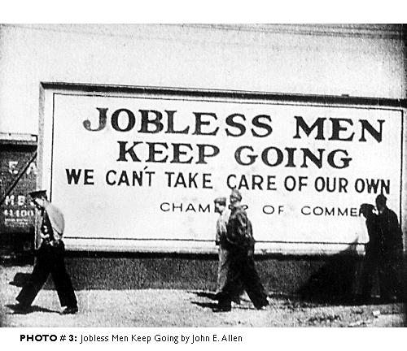

(A) The Impact of the Great Depression: Overview

After more than half a century, images of the Great Depression remain firmly etched in the American psyche: breadlines, soup kitchens, tin-can shanties and tar-paper shacks known as "Hoovervilles," penniless men and women selling apples on street corners, and gray battalions of Arkies and Okies packed into Model A Fords heading to California.
The collapse was staggering in its dimensions. Unemployment jumped from less than 3 million in 1929 to 4 million in 1930, to 8 million in 1931, and to 12 1/2 million in 1932. In that year, a quarter of the nation's families did not have a single employed wage earner. Even those fortunate enough to have jobs suffered drastic pay cuts and reductions in working hours. Only one company in ten failed to cut pay, and in 1932, three-quarters of all workers were on part-time schedules, averaging just 60 percent of the normal work week.
The economic collapse was terrifying in its scope and impact. By 1933, average family income had tumbled 40 percent, from $2,300 in 1929 to just $1,500 four years later. In the Pennsylvania coal fields, three or four families crowded together in one-room shacks and lived on wild weeds. In Arkansas, families were found inhabiting caves. In Oakland, California, whole families lived in sewer pipes.
Vagrancy shot up as many families were evicted from their homes for nonpayment of rent. The Southern Pacific Railroad boasted that it threw 683,000 vagrants off its trains in 1931. Free public flophouses and missions in Los Angeles provided beds for 200,000 of the uprooted.
To save money, families neglected medical and dental care. Many families sought to cope by planting gardens, canning food, buying used bread, and using cardboard and cotton for shoe soles. Despite a steep decline in food prices, many families did without milk or meat. In New York City, milk consumption declined by a million gallons a day.
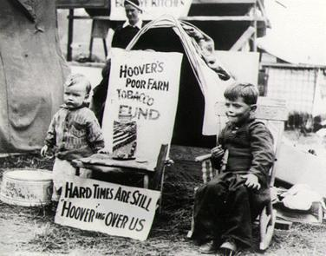

President Herbert Hoover declared, "Nobody is actually starving. The hoboes are better fed than they have ever been." But in New York City in 1931, there were 20 known cases of starvation; in 1934, there were 110 deaths caused by hunger. There were so many accounts of people starving in New York that the West African nation of Cameroon sent $3.77 in relief.
The Depression had a powerful impact on families. It forced couples to delay marriage and drove the birthrate below the replacement level for the first time in American history. The divorce rate fell, for the simple fact that many couples could not afford to maintain separate households or to pay legal fees. Still, rates of desertion soared. By 1940, there were 1.5 million married women living apart from their husbands. More than 200,000 vagrant children wandered the country as a result of the break-up of their families.
The Depression inflicted a heavy psychological toll on jobless men. With no wages to punctuate their ability, many men lost power as primary decision makers. Large numbers of men lost self-respect, became immobilized and stopped looking for work, while others turned to alcohol or became self-destructive or abusive to their families.
In contrast to men, many women saw their status rise during the Depression. To supplement the family income, married women entered the work force in large numbers. Although most women worked in menial occupations, the fact that they were employed and bringing home paychecks elevated their position within the family and gave them a say in family decisions.
Despite the hardships it inflicted, the Great Depression drew some families closer together. As one observer noted: "Many a family has lost its automobile and found its soul." Families had to devise strategies for getting through hard times because their survival depended on it. They pooled their incomes, moved in with relatives in order to cut expenses, bought day-old bread, and did without. Many families drew comfort from their religion, sustained by the hope things would turn out well in the end; others placed their faith in themselves, in their own dogged determination to survive that so impressed observers like Woody Guthrie. Many Americans, however, no longer believed that the problems could be solved by people acting alone or through voluntary associations. Increasingly, they looked to the federal government for help.
