Theodore Wright Bartow High School American Imperialism DBQ

Directions: Read each of the documents below and answer the questions that follow. When you have finished, use your knowledge from the documents and other prior knowledge to write an essay that answers the following question.

Essay Question: At the end of the 19th Century, to what extent was America imperialistic or was it simply an extension of Manifest Destiny of the Westward Expansion?

Definitions:

Imperialism: The policy of extending a nation's authority by territorial acquisition or by the establishment of economic and political hegemony over other nations.

Manifest Destiny: The 19th-century doctrine that the United States had the divine right and duty to expand throughout the North American continent.

Document 1

MR. PRESIDENT, the times call for candor. The Philippines are ours forever, "territory belonging to the United States," as the Constitution calls them. And just beyond the Philippines are China's illimitable markets. We will not retreat from either. We will not repudiate our duty in the archipelago. We will not abandon our opportunity in the Orient. We will not renounce our part in the mission of our race, trustee, under God, of the civilization of the world. And we will move forward to our work, not howling out regrets like slaves whipped to their burdens but with
gratitude for a task worthy of our strength and thanksgiving to Almighty God that He has marked us as His chosen people, henceforth to lead in the regeneration of the world.

Senator ALBERT J. BEVERIDGE : In Support of an American Empire 1899

1. What justification does Senator Beveridge make for the American control of the Philippines?

2. What does Senator Beveridge say is the mission of the United States?

"I walked the floor of the White House night after night until midnight; and I am not ashamed to tell you, gentlemen, that I went down on my knees and prayed Almighty God for light and guidance more than one night. And one night late it came to me this way...(1) that we could not give them back to Spain -- that would be cowardly and dishonorable; (2) that we could not turn them over to France or Germany -- our commercial rivals in the Orient -- that would be bad business and discreditable; (3) that we could not leave them to themselves
-- they were unfit for self government -- and they would soon have anarchy and misrule worse than Spain's was; and (4) that there was nothing left for us to do but take them all, and to educate the Filipinos, and uplift and civilize them, and by God's grace do the very best we could by them..."

William McKinley, speech to a Methodist Church group, November 1899

3. What are McKinley’s justifications for keeping the Philippines?

4. What are some positive reasons for keeping the Philippines?

Document 3

The course of Americanism has been in natural order, a little rough sometimes, it is true, but that, too, is in the nature of things. What these people call imperialism is only mirage in the heated air of politics --- and it will entirely disappear when the snow flies again. The trouble with the Philippines has been occasioned by Aguinaldo and his associates. Americans are there of right, and they ask nothing of the natives but to go ahead with their business; they will not only be protected in every right, but will be aided by all powerful influences of an advanced and aggressive civilization

Peffer, W. A., "Imperialism: America's Historic Policy," The North American Review, vol. 171, issue 525 (August 1900).

5. What is the justification of the keeping of the Philippines made by this article?

6. Who is to be blamed for the problems in the Philippines?

Document 4

What is our title to the Philippine Islands? Do we hold them by treaty or by conquest? Did we buy them or did we take them? Did we purchase the people? If not, how did we secure title to them? Were they thrown in with the land? Will the Republicans say that inanimate earth has value but that when that earth is molded by the Divine Hand and stamped with the likeness of the Creator it becomes a fixture and passes with the soil? If governments derive their just
powers from the consent of the governed, it is impossible to secure title to people, either by force or by purchase.

We could extinguish Spain's title by treaty, but if we hold title we must hold it by some method consistent with our ideas of government. When we made allies of the Filipinos and armed them to fight against Spain, we disputed Spain's title. If we buy Spain's title, we are not innocent purchasers. There can be no doubt that we accepted and utilized the services of the Filipinos and that when we did so we had full knowledge that they were fighting for their own independence; and I submit that history furnishes no example of turpitude baser than ours if we now substitute our yoke for the Spanish yoke. . . .

WILLIAM JENNINGS BRYAN : The Paralyzing Influence of Imperialism

Source: Official Proceedings of the Democratic National Convention Held in Kansas City, Mo., July 4, 5 and 6, 1900, Chicago, 1900, pp. 205-227.

7. What is Mr. Bryan’s argument against the keeping of the Philippines?
8. How is it impossible to secure power to the people?

Document 5

The United States have always protested against the doctrine of international law which permits the subjugation of the weak by the strong. A self-governing state cannot accept sovereignty over an unwilling people. The United States cannot act upon the ancient heresy that might makes right...When the white man governs himself, that is self-government, but when he governs himself and also governs another man, that is more than self-government -- that is despotism.

The Anti-Imperialist League, 1899.

9. What has the United States always protested against?
10. What is despotism?

First we will in no way interfere with any treaty port or any vested interest within any so- called "sphere of interest" or leased territory it may have in China. Second. That the Chinese treaty tariff of the time being shall apply to all merchandise landed or shipped to all such ports as are within said "sphere of interest" (unless they be "free ports"), no matter to what nationality it may belong, and that duties so leviable shall be collected by the Chinese Government.

Secretary of State John Hay, First Open Door Note 1899

11. What will the United States not interfere with?
12. What will levies be collected by?

Document 7

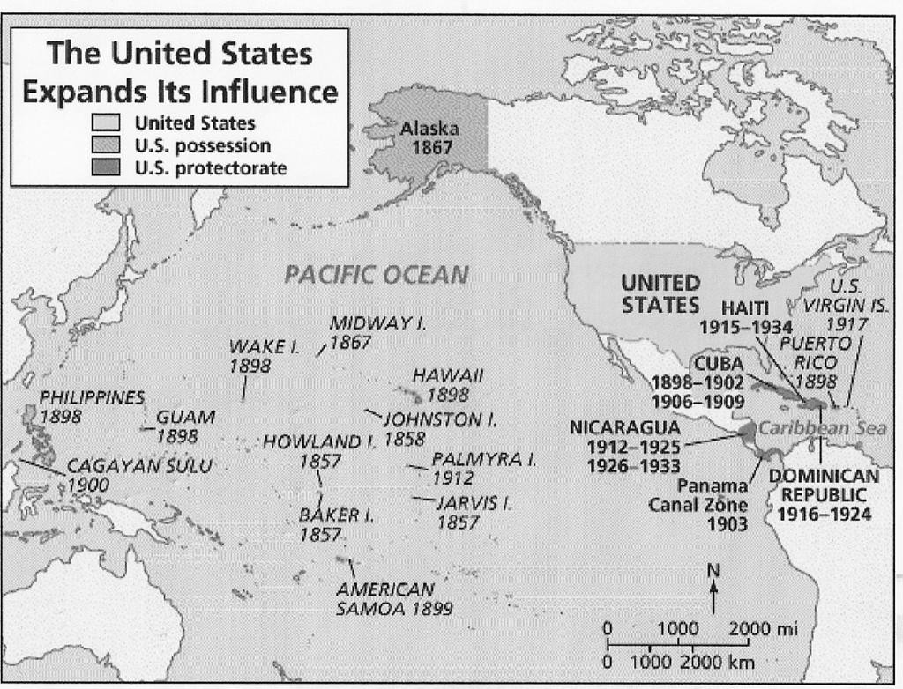

13. What is the first overseas possession of the United States?
14. What possessions came after the Philippines?

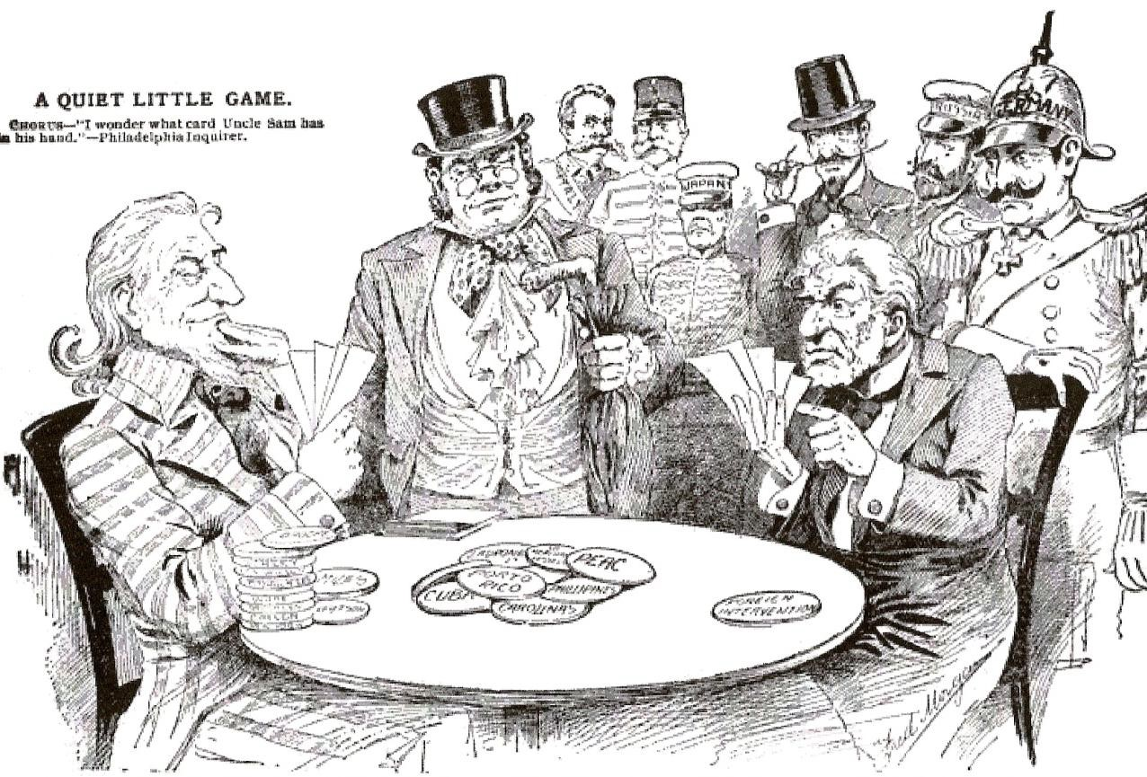

15. Who are the participants in the game?
16. What are they playing for?

