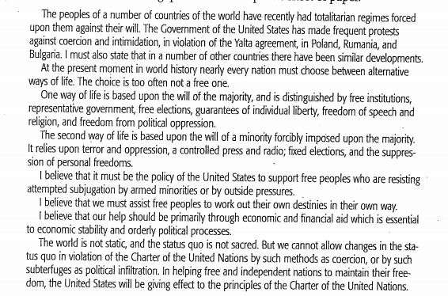

Read the excerpt above from Truman’s speech to Congress, delivered March 12, 1947, which came to be known as the Truman Doctrine. Based on this excerpt, answer the following questions.
1: A) Which sentence states what Truman is asking for? Highlight or underline it.
B) Which two words/phrases support your answer to part A.?
A: free institutions/free elections
B: economic/financial aid
C. Status quo/coercion
D. terror/oppression

2. In the “first and second ways of life”; Truman refers to which one representing the ideals of democracy?

3. Give a modern day example of a country that lives by the “first way of life” as described by Truman?

4. Give a modern day example of a country that lives by the “second way of life” as described by Truman?

5. Which two words would best replace coercion and subterfuges in the last paragraph in Truman’s speech?
A. force/deceptive
B. persuasion/scheme
C. threatening/ dishonesty
D. control/ fairness

