Becoming a World Power 1872-1912

Pre-Read the Vocabulary: This will help you understand the passage.
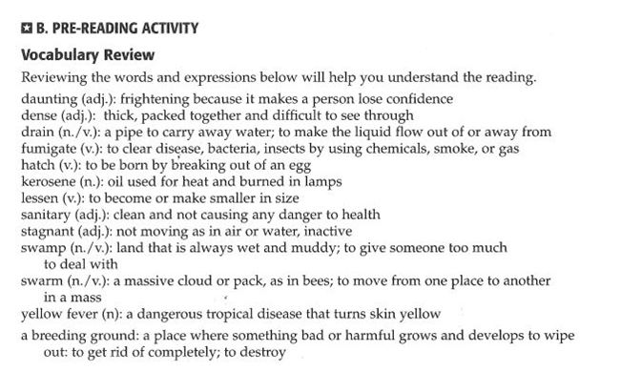

Read the passage and answer the questions that follow.

