IMPACT OF THE CIVIL RIGHT MOVEMENT: Read the three excerpts below and answer the questions that follow.

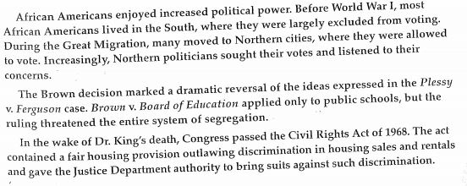
- Which statement below best expresses the impact on the Civil Rights movement of excerpt #1.
- African Americans were moving north.
- African Americans were not allowed to vote in the south.
- African Americans were gaining political power and voice.
- Politicians listened to African Americans after WWI.

- Which statement below best expresses the impact on the Civil Rights Movement of excerpt #2.
- Brown v. Board began to change the social system.
- Plessey v. Ferguson didn’t apply to schools.
- Brown v Board applied only to schools.

- Which statement below best expresses the impact on the Civil Rights Movement of excerpt #3.
- African Americans began to make economic gains after Dr. King’s death.
- Dr. King died before the Civil Rights Act of 1968 was passed.
- The Justice Department could bring suit against those discriminating in housing.

List a social, political and economic outcome that might have occurred for each event.

- Excerpt 1. Social

Political

Economic

- Excerpt 2. . Social

Political

Economic

- Excerpt 3. Social

Political

Economic

