WARM UP EISENHOWER AND LITTLE ROCK

View the video of President Eisenhower addressing the nation regarding Central High School in Little Rock, Arkansas.
Take notes on the main points the President Makes in his address.
http://www.c-span.org/video/?15186-1/eisenhower-speech-little-rock

Read the following excerpt about President Eisenhower’s decision to uphold federal authority in the integration of Central High School in Little Rock, Arkansas. Use your notes from the video and the excerpt answer the questions that follow.

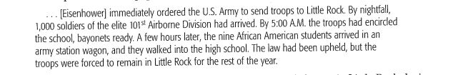

- What does this one event say about the political and social climate in Little Rock during this time?
- Why was Eisenhower’s decision risky considering the climate of the nation during the Cold War?

