CHAPTER 22: THE GREAT DEPRESSION AND THE NEW DEAL

KEY TERM | EXPLANATION
Teapot Dome Scandal (p. 375)
Hawley-Smoot Tariff
Hoovervilles
Reconstruction Finance Corporation
Bonus Army
Glass-Steagall/FDIC
CCC
AAA
TVA
Social Security
Wagner Act
Court-Packing Plan
Keynesianism

KEY QUESTION | EXPLANATION
What basic economic and political policies were pursued by the three conservative Republican administrations of the 1920s? (p. 375)
What were the long-term and short-term causes of the Great Depression? | LONG-TERM | SHORT-TERM
How did Hoover respond to the various problems of the Great Depression? Evaluate the effectiveness of his responses.
What were the causes and consequences of the Dust Bowl? | CAUSES | CONSEQUENCES
How did FDR attempt to provide Relief, Recovery and Reform in the First New Deal? | RELIEF | RECOVERY
 | REFORM
Who were the major critics of the New Deal? What impact did they have on FDR’s New Deal?
What were the most important successes and failures of the New Deal? | SUCCESSES | FAILURES

UNIT 6 SOURCE ANALYSIS

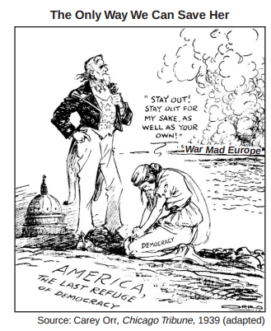
- Briefly explain one perspective of foreign affairs expressed in the image.

- Briefly explain one specific historic event that led to the development of this perspective.

- Briefly explain one specific effect that resulted from the political developments expressed in the image.

