APUSH UNIT 5 READING GUIDE Name:______________________________

UNIT 5
THE GILDED AGE

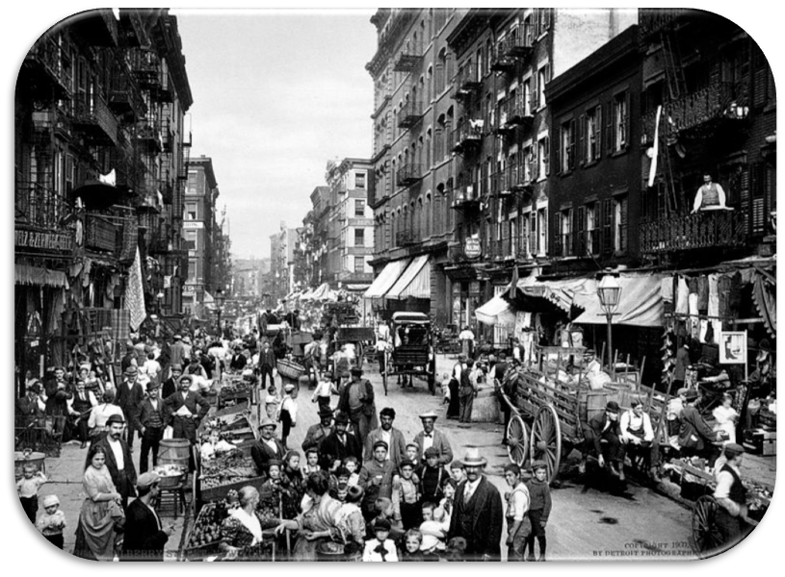

Chapter 17 | Chapter 18 | Chapter 19
CHAPTER 17: THE INDUSTRIAL REVOLUTION

KEY TERM | EXPLANATION
Gilded Age (p. 313)
Transcontinental Railroad (p. 293)
Gospel of Wealth (look beyond the textbook)
Social Darwinism
John Muir
Triangle Shirtwaist Fire
Pendleton Act
Yellow Dog Contract
Great Railroad Strike
Haymarket Square Riot

KEY QUESTION | EXPLANATION
What were the main causes of industrial growth in the Gilded Age?
What developments occurred in the industrial age that allowed for the creation of a national marketplace and modern consumer culture?
Describe the tactics that each of the following business leaders used to amass their wealth. What evidence is there to suggest that each of the following men was a “Captain of Industry” or a “Robber Baron”? (find evidence from both perspectives) | ANDREW CARNEGIE (explain Vertical Integration) | JOHN ROCKEFELLER (explain Horizontal Integration)
 | J.P. MORGAN
What types of harmful business practices developed during the Gilded Age? How did business leaders justify these actions?
Describe the political corruption that occurred during the Gilded Age and its impact on the political climate of the late 1800s (focus on Boss Tweed and Tammany Hall)
Discuss the goals, activities and achievements of the major labor unions discussed in Chapter 17 | KNIGHTS OF LABOR | AMERICAN FEDERATION OF LABOR
 | INTERNATIONAL WORKERS OF THE WORLD

CHAPTER 18: THE INDUSTRIAL AGE

KEY TERM | EXPLANATION
Tenements
New South
Atlanta Compromise
Battle of Little Bighorn
Wounded Knee Massacre
Dawes Act
Chinese Exclusion Act
Homestead Act
Gold Standard
Inflation

KEY QUESTION | EXPLANATION
Provide examples of how the Industrial Revolution brought change to urbanization and immigration in the North
In what ways did the South attempt to reshape their image and economy post-Reconstruction? How successful were these efforts?
Describe the goals and strategies each of the following African American leaders used to respond to the racial injustices of their time: | BOOKER T. WASHINGTON | IDA B. WELLS
 | W.E.B. DUBOIS | MARCUS GARVEY (P. 378-379)
Describe the role that industrialization played in shaping the following features of “the West.” | FARMING | INDUSTRY
 | CHICAGO
What were the causes and consequences of the “Indian Wars” in the West from 1864-1890? | CAUSES | CONSEQUENCES
What were the main goals of the Populist/People’s Party? How successful were they at achieving their goals?
What were the main issues in the crucial campaign of 1896? Why did McKinley win, and what were the long-term effects of his victory?

CHAPTER 19: THE PROGRESSIVE ERA

KEY TERM | EXPLANATION
Social Gospel
Settlement Houses
Initiative
Referendum
Margaret Sanger
Sherman Antitrust Act
New Freedom
Federal Reserve
Muckraker
Meat Inspection Act
Pure Food & Drug Act
Scientific Management
16th, 17th, 18th and 19th Amendments
(outside info)
Eugenics

KEY QUESTION | EXPLANATION
Who were the “Progressives” and what were their shared missions/beliefs?
Describe the major reforms that the Progressives brought to the following areas: | URBAN LIFE | AMERICAN POLITICS
 | BUSINESS PRACTICES/LABOR | PRESERVATION/CONSERVATION
Compare and contrast the accomplishments/reforms of Teddy Roosevelt and Woodrow Wilson during their presidencies | TEDDY ROOSEVELT | WOODROW WILSON
What were the major limitations of the Progressive movement? Where did they fail to achieve reforms?

UNIT 5 SOURCE ANALYSIS

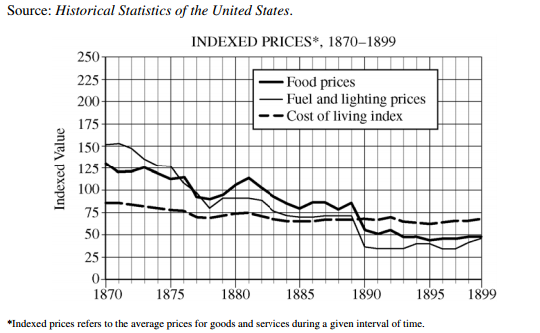
- Briefly explain one specific historical development that contributed to the emergence of the patterns depicted in the chart.

- Briefly explain another specific historical development that contributed to the emergence of the patterns depicted in the chart.

- Briefly explain one specific historical effect that resulted from the patterns depicted in the chart.

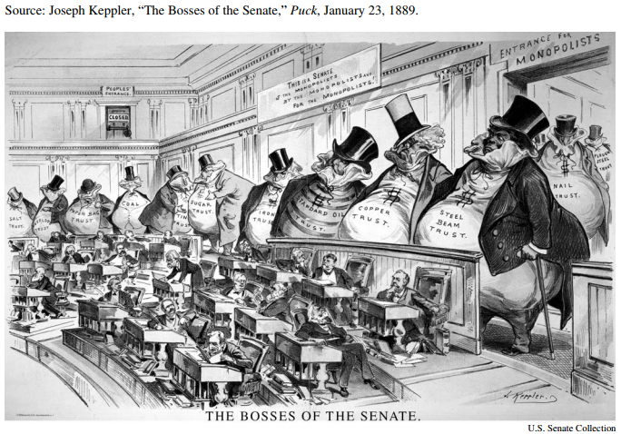
- Briefly explain one perspective of politics in the Gilded Age expressed in the image.

- Briefly explain one specific historic event that led to the development of this perspective.

- Briefly explain one specific effect that resulted from the political developments expressed in the image.

