APUSH UNIT 2 READING GUIDE Name:______________________________

UNIT 2
AMERICAN INDEPENDENCE

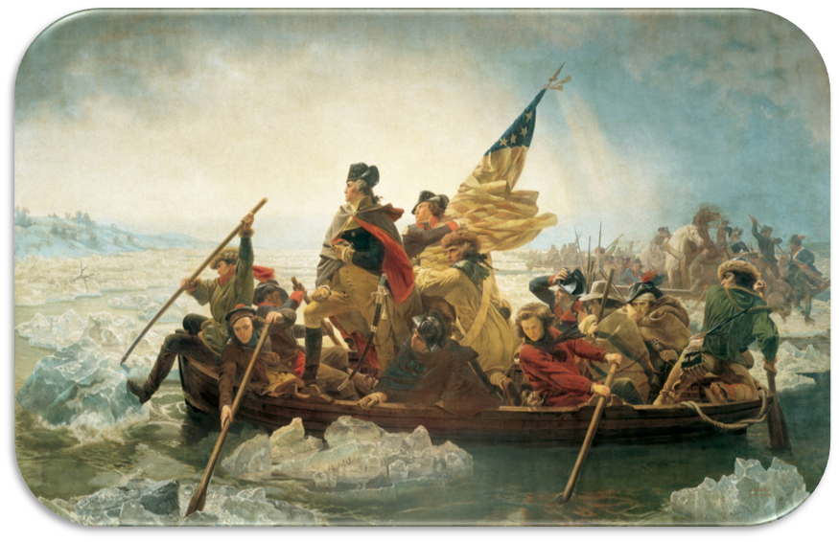

Chapter 5 | Chapter 6 | Chapter 7 | Chapter 8

CHAPTER 5: TOWARD REVOLUTION

KEY TERM | EXPLANATION
Proclamation Line of 1763
Benjamin Franklin
Enlightenment (p. 69)
Stamp Act
Virtual Representation
Townshend Acts
Intolerable Acts
Sons & Daughters of Liberty
George III
Thomas Hutchinson

KEY QUESTION | EXPLANATION
Why (and how) did the British attempt to rein in the colonies following the French & Indian War?
Why did the Stamp Act make the colonists so angry? How did the British react to the colonial protests?
Explain how each event caused the next event to happen. | Stamp Act --->Townshend Acts | Townshend Acts--->Boston Massacre
 | Tea Act --->Boston Tea Party | Boston Tea Party --->Intolerable Acts
 | Intolerable Acts --->First Continental Congress | First Continental Congress --->Battle of Lexington & Concord
What was so “intolerable” about the Coercive Acts? How did American colonists react to them?

CHAPTER 6: THE REVOLUTION

KEY TERM | EXPLANATION
Lord Dunmore’s Proclamation
Hessians
Loyalists
Republicanism
Republican Motherhood

KEY QUESTION | EXPLANATION
Why were colonists reluctant to withdraw from the British Empire and declare their independence?
What were the military advantages of the British and American colonists on the eve of the American Revolution? | BRITISH ADVANTAGES | AMERICAN ADVANTAGES
Describe each event, then explain how it became a turning point in the American Revolution. | 2ND CONTINENTAL CONGRESS | COMMON SENSE
Describe each event, then explain how it became a turning point in the American Revolution. | DECLARATION OF INDEPENDENCE | NEW YORK CAMPAIGN (1776)
 | BATTLE OF TRENTON & PRINCETON | BATTLE OF SARATOGA
 | WINTER AT VALLEY FORGE | BRITAIN’S SOUTHERN PLAN
 | BATTLE OF YORKTOWN | TREATY OF PARIS
Assess the significance of the Revolutionary War by providing examples of its impact on... | POLITICS | AMERICAN NATIONALISM
 | SLAVERY | NATIVE AMERICANS
 | WOMEN | RELIGIOUS MINORITIES

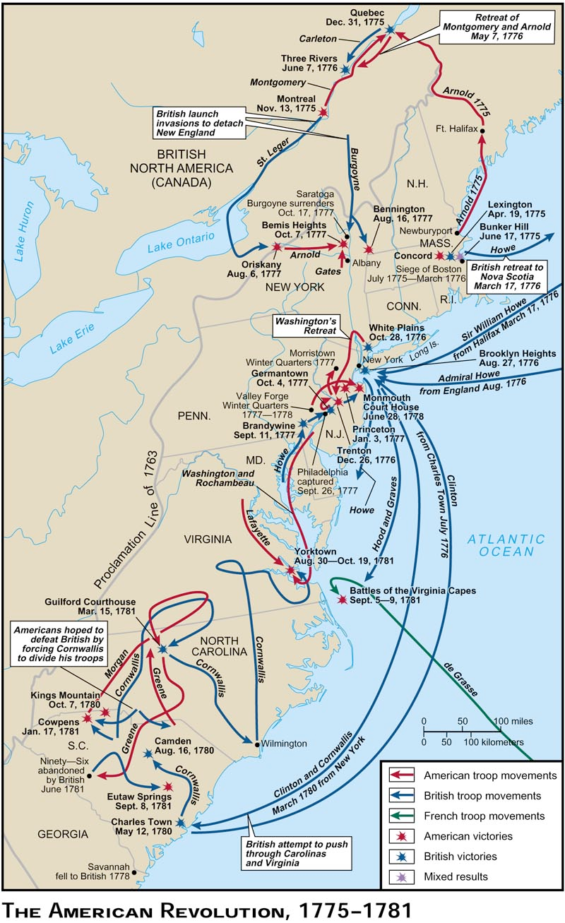
THE AMERICAN REVOLUTION, 1775-1781:

According to this map, in which colonial region did the Revolutionary War begin?

According to this map, in which colonial region did the middle phase of the Revolutionary War occur?

According to this map, in which colonial region did the Revolutionary War end?

CHAPTER 7: CONFEDERATION AND CONSTITUTION

KEY TERM | EXPLANATION
Articles of Confederation
Land Ordinance of 1785
Northwest Ordinance of 1787
Shays’ Rebellion
James Madison
Separation of Powers
Electoral College
Federalist Papers

KEY QUESTION | EXPLANATION
Describe the first state constitutions written and adopted after the United States declared its independence. What common features did they share?
What were the successes and failures of the Articles of Confederation? | SUCCESSES | FAILURES
What events and situations motivated a desire for a stronger central government and a revision of the Articles of Confederation?
Describe the basic ideas and goals of the Founding Fathers in the Philadelphia Constitutional Convention and how they incorporated their fundamental principles into the Constitution.
What compromises were required to produce the Constitution?
In what ways was the Constitution a radical departure from the Articles of Confederation?
Who were the Federalists and Antifederalists? What were the issues that divided them, and why did the Federalists win?
What important protections were added to the Constitution in the Bill of Rights?
Some historians have argued that the Constitution was revolutionary and it elevated the ideals of the American Revolution. Other historians have argued that it was counter-revolutionary, meaning that it tried to set limits and boundaries on the American Revolution and was very conservative in nature. Find evidence that supports each side of the argument from throughout the chapter.

CHAPTER 8: SECURING THE NEW NATION

KEY TERM | EXPLANATION
Patronage
Tariff
Democratic-Republicans
Loose Construction
Whiskey Rebellion
Impressing
Jay’s Treaty
Haitian Revolution
Washington’s Farewell Address (refer to sources beyond the textbook, what did he warn the country about?)
Alien & Sedition Acts
Nullification
Revolution of 1800

KEY QUESTION | EXPLANATION
What were the components of Hamilton’s financial plan, and what did he hope to accomplish with that policy?
What were the philosophical differences between Hamilton’s “Federalists” and Jefferson’s “Republicans”? | HAMILTON | JEFFERSON
What were the major successes and failures of George Washington’s presidency? (consider domestic and foreign policies) | SUCCESSES | FAILURES
What were the causes and consequences of Jay’s Treaty? | CAUSES | CONSEQUENCES
What were the causes and consequences of the Alien & Sedition Acts? | CAUSES | CONSEQUENCES

