APUSH UNIT 1 READING GUIDE Name:______________________________

Periods 1 & 2
COLONIAL BEGINNINGS

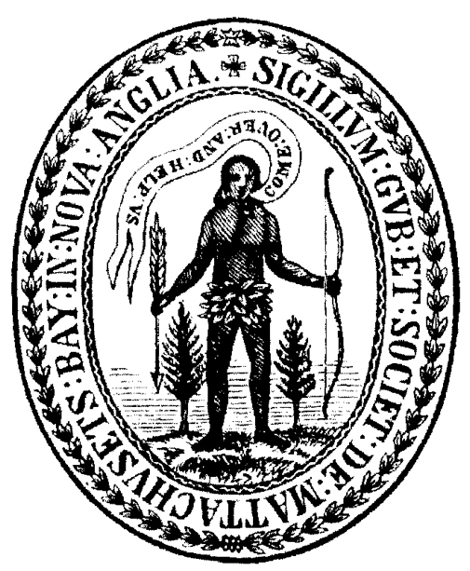

Chapter 1 | Chapter 2 (Part 1) | Chapter 2 (Part 2) | Chapter 3 | Chapter 4
CHAPTER 1: THREE SOCIETIES ON THE VERGE OF CONTACT

Key Terms: Explain and describe the historical significance of the following terms. Your answer should be detailed enough to prove that you actually read the chapter. Each definition should explain “what it is” and “why it’s important.”
Example: Soil Butchery - What it is: The excessive cultivation of the land making it useless. Why it’s important: The search for better land forced settlers westward, causing continued confrontation with local native american populations.

KEY TERM | EXPLANATION
Inca
Aztec
Cahokia
Iroquois Confederacy

Key Questions: As you read the chapter, focus on attempting to understand these key questions. Each answer should contain evidence from the textbook to prove that you read the chapter. Try to paraphrase the textbook and put things in your own words, rather than “copy shapes.” Answers will vary in length, but be sure to exhaust all evidence when answering a question. If a question asks about “causes”, explain ALL possible causes to an event, not just one.

KEY QUESTION | EXPLANATION
Describe two theories for how the first human beings arrived in North America. What evidence supports these theories? | THEORY #1 | THEORY #2
How did maize transform early Native American societies?
Provide examples of how each of the following Native American societies adapted to their environments. Next provide examples of how the environment shaped their societies. | ANASAZI/SOUTHWEST | MISSISSIPPIANS
 | NORTHEAST | PRAIRIES/HIGH PLAINS
 | NORTHWEST
Compared to Africa and Europe, how “advanced” were Native American societies before European contact? Provide evidence that supports your answer.

CHAPTER 2 (PART 1): CONTACT AND SETTLEMENT, PAGES 22-31

KEY TERM | EXPLANATION
Prince Henry the Navigator
Conquistador
Encomienda
Cortés
Pizarro
Columbian Exchange

COLONIAL EMPIRES MAP: Add lines that indicate the routes that Columbus took in his explorations. Also label and color the colonial empires for: Spain, Portugal, France, Britain, Russia and the Dutch (Refer to p. 28 and resources beyond the textbook to complete this map)

KEY QUESTION | EXPLANATION
What factors contributed European desires to explore lands outside Europe and Christopher Columbus’s “discovery” of the New World in 1492?
What tactics did Spain use to establish an empire in the New World?
How did the Columbian Exchange transform the Eastern and Western Hemispheres? | EASTERN HEMISPHERE | WESTERN HEMISPHERE
What international events and domestic changes prompted England to begin exploration and colonization in the mid-1500s? (read “The Reasons Why…” section on p. 32)
CHAPTER 2 (PART 2): CONTACT AND SETTLEMENT, PAGES 31-41

KEY TERM | EXPLANATION
Joint-Stock Company
Charter
Indentured Servitude
Head right
Royal Colony
Proprietary Colony
Protestant Reformation (located in Ch. 1)
Puritans
Separatists

KEY QUESTION | EXPLANATION
What was the primary purpose of the English settlement of Jamestown, and how successful were the colonists in achieving that goal in the first twenty years?
In what ways did English colonists interact with Native Americans in Virginia? Why were Native Americans unable to repel the English colonization of North America?
What features were common to England’s Chesapeake colonies (Virginia and Maryland), and what features were peculiar or unique to each one?
Compare and contrast Massachusetts Bay Colony and Plymouth Colony - what were the major similarities and differences? | SIMILARITIES | DIFFERENCES
How did Puritan religion shape the government and society of Massachusetts Bay Colony? How “democratic” was Massachusetts Bay Colony? (additional info on p. 69-71)
How did religious intolerance play a role in the founding of other New England colonies?
Compare and contrast the early colonial empires of Spain, France and England in terms of motives for settlement, economies (how they made money), and relations with Africans and Indians. (Refer to info from throughout Ch. 2)

CHAPTER 3: EXPANSION AND ITS COSTS
(Skip readings on Middle and Southern Colonies, p. 43-48)

KEY TERM | EXPLANATION
Middle Passage (Ch. 4)
Chattel Slavery (refer to sources beyond the text)
Slave Codes
Pueblo Revolt
Stono Rebellion (Ch. 4)

KEY QUESTION | EXPLANATION
What were the causes and consequences of King Philip’s War? | CAUSES | CONSEQUENCES
How did Bacon’s Rebellion represent a turning point in American history? Describe what it was like before and after that event, or what made the event significant.
What factors allowed slavery to develop and expand in the English colonies in the seventeenth century? Why did slaves replace indentured servants over time? Additional info for this answer should come from Ch. 4, p. 73-77
As the population of African slaves increased in the colonies, what changes came about in colonial society? Additional info for this answer should come from Ch. 4, p. 73-77
How did Africans resist the dehumanizing aspects of slavery? Additional info for this answer should come from Ch. 4, p. 73-77
What trends or patterns do you notice in this map of the Atlantic slave trade? What might have cause these patterns to develop? | 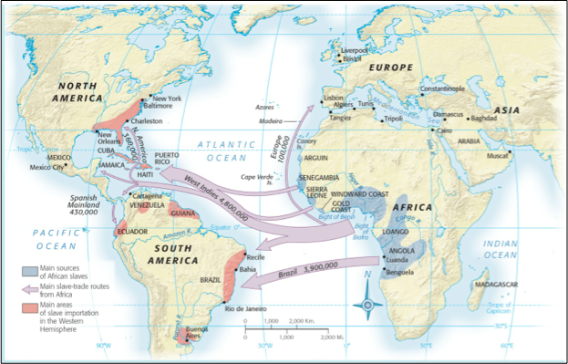

CHAPTER 4: EXPANSION AND CONTROL
(Skip readings on Slavery, p. 73-77)
KEY TERM | EXPLANATION
Navigation Acts (Ch. 3)
Salutary Neglect
Triangular Trade
Quakers (Ch. 3)
Zenger Trial
Mercantilism (p. 17)
Great Awakening
George Whitefield
Enlightenment
Albany Plan
Pontiac’s Rebellion

KEY TERM | EXPLANATION
What were the causes and consequences of the Great Awakening? | CAUSES | CONSEQUENCES
Provide examples of the various environmental, economic, cultural and demographic features that made each of the following regions unique: | NEW ENGLAND | MIDDLE COLONIES (Additional info on p. 46-48)
 | CHESAPEAKE | SOUTHERN COLONIES/WEST INDIES (Additional Info on p. 44-46, 49)
What were the causes and consequences of the salutary neglect approach that the British crown took with their colonies? (Additional info on p. 43-44) | CAUSES | CONSEQUENCES
How did colonial participation in transatlantic trade foster stronger bonds with Britain and simultaneously encourage resistance to British control? What were the advantages and disadvantages of being a British colony in the 1700s? | ADVANTAGES/ FOSTER STRONGER BONDS | DISADVANTAGES/ENCOURAGE RESISTANCE
What factors allowed colonial rivalries to intensify between Britain and France in the 17th and 18th centuries? What were the long term causes of the French & Indian War? Additional info on p. 51, 56-57, 77-79
Explain why the French and Indian War was a significant turning point for the colonies.

13 COLONIES MAP: Label and color the following regions on the map (Southern Colonies, Chesapeake Colonies, Middle Colonies, New England Colonies)

