Effects of the Great Depression
Group | Details  (3 specific ways this group was affected by the Great Depression) | Main Idea/Conclusion  ( 1 or 2 sentence statement summarizing how this group was affected by the Great Depression)
Overview

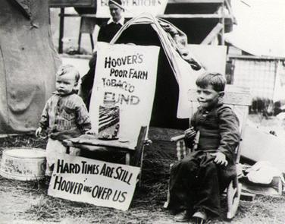

African Americans

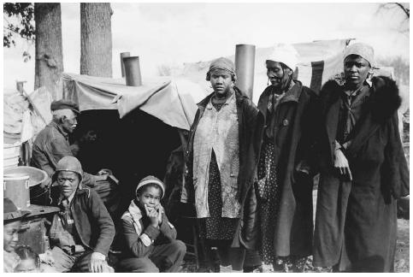

Mexican Americans

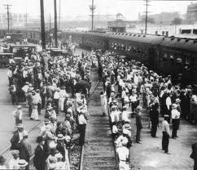

Women & Families

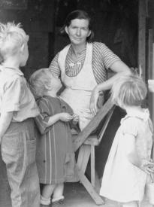

Farmers

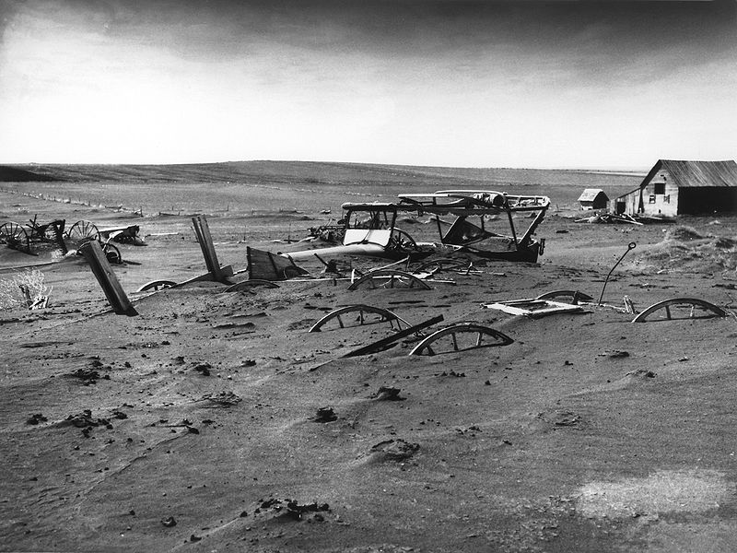

Migrant Workers

