In developing your answers, be sure to keep this general definition in mind:

discuss means "to make observations about something using facts, reasoning, and argument; to present in some detail.

This question is based on the accompanying documents. The question is designed to test your ability to work with historical documents. Some of the documents have been edited for the purposes of the question. As you analyze the documents, take into account the source of each document and any point of view that may be presented in the document.

Historical Context:

As the United States transformed into an industrialized nation, the effects of this massive change were felt at all levels of society. Industrialization had long-term social, economic, and political effects on American society.

Task: Using information from the documents and your knowledge of United States history and government, answer the questions that follow each document in Part A. Your answers to the questions will help you write the Part B essay in which you will be asked to:

• Discuss the social, economic, and political reactions to industrialization and urbanization in the United States from 1890 to 1920

Part A: Short Answer

Document#!

Today three-fourths of [New York's] people live in tenements. . .. The gang is the ripe fruit of tenement-house growth. It was born there, endowed with a heritage of instinctive hostility to restraint by a generation that sacrificed home to freedom, or left its country for its country's good . . .. New York's tough represents the essence of reaction against the old and the new oppression, nursed in the rank soil of its slums.
-Jacob Riis, How the Other Half Lives,1890

1. According to Jacob Riis, what problems developed as a result of urbanization?

Document-Based Question 173

Document#2

I insist that the true object of all true education is not to make men carpenters, it is to make carpenters men. ...
T1ze Talented Tenth of the Negro race must be made leaders of thought and missionaries of culture among their people. No others can do this work and Negro colleges must train men for it .
-W.E.B. Du Bois

2. According to DuBois, what should be the role of well-educated African Americans in society?

Document#3

!Primary Party leaders pick candidates for state and local offices | Voters select party's candidates
Initiative j Only members of state legislatures can  1 introduce bills | Votes can put bills before state legislatures
Referendum Only legislators pass laws | Voters can vote on bills directly
Recall . Only courts or legislatures can remove  i corrupt officials | Voters can remove elected officials from office

3. State one way in which Progressive legislation granted citizens greater participation in state governments.

174 Unit 4: The Progress1ve Movement

Document#4

It shall be unlawful for any person engaged in commerce . .. to discriminate in price between different purchasers of commodities of like grade and quality . .. where the effect of such discrimination may be substantially to lessen competition or tend to create a monopoly. .. .

No person engaged in commerce . .. shall acquire . .. the whole or any part of the stock . . . where in any line of commerce or in any activity affecting commerce in any sectimt of the cou ntry, til e effect of such acquisition may be substantially to lessen competition, or to t end to create a monopoly.
-Clayton Antitrust Act

4. What effect did the Clayton Antitrust Act have on monopolies such as Standard Oil?

Document#5

Value of United States Exports, 1870-1920

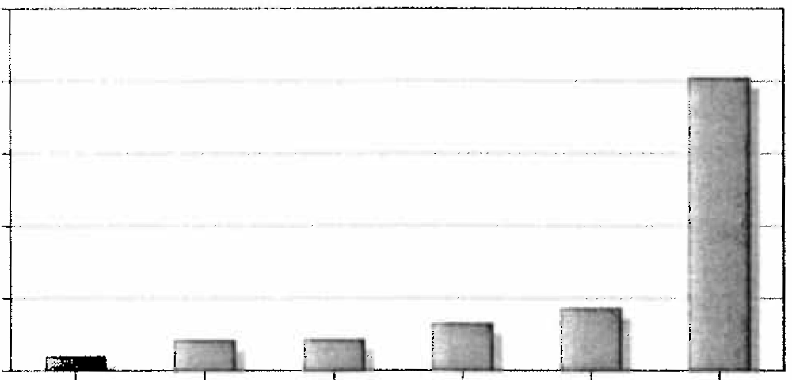10

c 8
"'
.:!
.., 6
-c
4

0
c 2

0
1870 1880 1890 1900 1910 1920
Year
Source: Historical Statistics of the United States, Colonial Times to 1970

5. Based on this graph and your knowledge of United States history, how did industrialization affect the activity of American businesses in international markets?

Document-Based Question 175

Part B

Essay
Directions: Write a well-organized essay that includes an introduction, several paragraphs, and a conclusion. Use evidence from at least three documents in your essay. Support your response with relevant facts, examples, and details. Include additional outside information.

Historical Context:

As the United States transformed into an industrialized nation, the effects of this massive change were felt at all levels of society. Industrialization had long-term social, economic, and political effects on American society.

Task:

Using information from the documents and your knowledge of United States history and government, write an essay in which you: •

• Discuss the social, economic, and political reactions to industrialization and urbanization in the United States from 1890 to 1920

Guidelines:

ln your essay, be sure to

• Address all aspects of the task.
• Develop all aspects of the task
• Incorporate information from at least three documents
• Incorporate relevant outside information
• Support the theme with relevant facts, examples, and details
• Use a logical and clear plan of organization, including an introduction and conclusion that are beyond a restatement of the theme.

176 Unit 4: The Progressive Movement

